# **Living Contradictions: Is Democracy a Prerequisite for LGBT Liberties?**

**Phillip Post**

***\*Olin College of Engineering***

***1000 Olin Way Needham, MA, USA***

ppost@olin.edu

## **Abstract**

Lesbian, Gay, Bisexual, and Transgender (LGBT) legal and social acceptance has a high correlation with the levels of democracy in their respective nations. Existing research has attributed this correlation to the core tenants of democracy (i.e. universal protections, liberties, and rights) being prerequisites for LGBT liberties to flourish. However, democracy does not guarantee that these liberties will form. This discrepancy was explored by plotting all internationally recognized countries, for which data exists between 2022 to 2023, Equaldex legal and social LGBT indices against their V-Dem average democracy levels. Outliers were then chosen that fit within one of two categories: democracies that are unusually intolerant of LGBT people or authoritarian regimes that are exceptionally tolerant. According to this standard, three outlier democracies and two outlier authoritarian regimes were found. Between the two authoritarian regimes, Cuba and Kazakhstan, Cuba proved to be the only real outlier as Kazakhstan’s legal protections are not upheld and LGBT hate attacks are common. Cuba had exceptionally high levels of LGBT legal and social liberties due to a grassroots public campaign that culminated in a successful referendum to consolidate LGBT liberties, yet this democratic victory only occurred with the permission of Cuba’s authoritarian regime. All three of the democracies with exceptionally low LGBT liberties, Jamaica, Malaysia, and Ghana, were former British colonies that retained colonial anti-sodomy laws. They also all shared a highly religious majority and governments that exploited the LGBT minority as threats against their religion and family structures. This study argues that democracy can be considered a prerequisite for LGBT liberties but only when those rights come solely from solely the government (i.e. top-down). Cuba, which had far higher LGBT liberties than the democracies analyzed, demonstrates that democracy was not a requirement when the decision for LGBT liberties came from overwhelming popular support (i.e. bottom-up).

# Introduction

For the scope of this research, the term Lesbian, Gay, Bisexual, and Transgender (LGBT) will be used when referring to gender and sexual minorities. While far from exhaustive, this term aligns with the indices used by this research. Table 1 provides a definition of each gender and sexuality reflected within LGBT.  
Table 1. Definition of Lesbian, Gay, Bisexual, Transgender, and Intersex[1]

| **Term** | **Definition** |
| --- | --- |
| Lesbian | A woman who has sexual/romantic orientation toward women |
| Gay | A man who is attracted to men in an emotional, romantic, or erotic sense |
| Bisexual | A person who experiences sexual, romantic, or physical attraction to more than one gender |
| Transgender | A person that has a sense of identity or gender that does not correspond to the gender they were assigned at birth |

Political restrictions usually come in the form of discriminatory military, citizenship, or marriage requirements and exclusions. Furthermore, political restrictions can make LGBT identities or relationships outright illegal with penalties ranging from fines to death. On the public side, LGBT groups can face social stigmatization, such as exclusion from purchasing goods and services to nonstate-sanctioned public beatings. Broadly speaking, democracies tend to tolerate and protect the LGBT minority whereas non-democracies suppress them; furthermore, established research has established that democracy is a requirement for LGBT liberties to form. Therefore, authoritarian non-democracies should not have robust LGBT liberties, especially ones that far exceed those of democracies. This research assesses whether or not this established trend has notable caveats.

# Literature Review

Established research has found an interesting quandary: the conditions for LGBT rights only exist within democracies yet not all democracies have these rights.[2] The first point makes intuitive sense as the principle of an authoritarian state (i.e. submission to an absolute authority at the cost of individual rights) is inherently opposed to a person’s gender or sexual freedom. On the other hand, democracy tends to enshrine political freedoms, civil society, and a robust rule of law, which provides a favorable environment for LGBT rights.[3] However, the second point indicates a favorable environment does not guarantee that these rights may form, which raises the question of when democracies are intolerant of the LGBT minority.

Alvarez’s research pursued the significance of democracy in connection to sexual and gender human rights.[4] To do this, they compared Brazil, Bulgaria, and Nigeria, which share a similar “political system (liberal democracy), regional influence (positive), religion (high), and Gross Domestic Product per capita (low); while they differ in legal protections enjoyed by gender and sexual minorities”.[5] These four shared similarities were based on factors that existing literature has connected to being predictive of LGBT liberties. As previously discussed, a political system can provide the opportunity for gender and sexual minority rights to flourish or perish. Regional influence embodies the effect of regional neighbors to emulate changes based on policies or judicial decisions made in neighboring nations whether this be regressive or progressive.[6] Religion is another factor that exists beyond national borders, and research has found high levels of religiosity to be correlated with negative attitudes against LGBT people.[7] Furthermore, traditional interpretations of religions are often at odds with nonconforming genders or sexualities as they emphasize traditional family roles and heterosexual relationships. Lastly, multiple connections have been found between economic strength or growth and LGBT rights, which can be split between internal and external. Internal economic forces such as decreases in economic growth and productivity have been connected to violence against LGBT groups, and stronger economies tend to be more inclusive of LGBT people.[8] This is caveated by the inconclusion on whether higher levels of inclusion cause higher levels of economic development or whether more developed economies lead to more rights. External economic forces come from international trade or funding from international organizations, both of which can be imperiled by the repression of the LGBT minority.[9]

Brazil had the strongest LGBT liberties and protections due to its federally recognized right to civil union, local LGBT protections for 70% of the population, right for same-sex couples to adopt children, and banning of conversion therapies.[10] Bulgaria had a mix of protections and discriminatory policies with employment protections for sexual and gender minorities, protections against sexual hate speech, and the signing of the Copenhagen Criteria, which requires protections for minorities.[11] Yet, Bulgaria has outlawed same-sex unions or adoption by same-sex couples, removed legal procedures for trans people to change their legal name, and removed gender-related curriculum from schools.[12] Lastly, Namibia had the worst gender and sexual minority rights out of the three due to its colonial sodomy laws that ban any relationship per annum between two human males and the consistent harassment of the LGBT community by law enforcement.[13]

With all three of these nations being considered liberal democracies yet having such varied levels of LGBT protections or restrictions, Alvarez found that “democracy should be taken as [a] necessary condition but not essential”.[14] The case of Brazil, Bulgaria, and Namibia show that liberal democracy lays a path for LGBT rights, but a combination of social attitudes, historically discriminatory laws, and repressive law enforcement tactics still repress sexual and gender minorities. Brazil’s robust protections are attributed to a strong social movement born out of the 1980s AIDS epidemic, which worked closely with nongovernmental organizations (NGOs) that were connected with the bureaucracy.[15] The LGBT rights movement also formed alliances with center-left, pro-globalization political groups, meaning they had a lever in pushing for LGBT liberties when the left-leaning Worker’s Party came to power.[16] Bulgaria is an interesting case because, rather than a bottom-up change originating in social movements, Alvarez attributes its sexual and gender minority rights to top-down changes imposed as requirements for joining the European Union (EU).[17] This explains why many of its restrictions (e.g. gender curriculum in schools or recognition of same-sex marriage) seem to stem from a lack of social acceptance from its population as LGBT protections did not originate from the population itself. Lastly, Namibia’s lack of any protections for LGBT people and harsh restrictions are ascribed to a weak civil society, blocking a bottom-up approach as seen in Brazil, and non-Western societies focus on collective rights instead of Western individual liberty ideals. The difference maker between the ascension of LGBT rights in Brazil and to a lesser extent Bulgaria versus the heavy restrictions in Namibia seems to be a combination of international pressure (e.g. policies implemented in neighboring countries or joining international organizations like the EU) as well as whether there is a robust social movement advocating for LGBT rights.

Through their research, Encarnacion explored the connection between gay rights and democracy, noting a similar quandary: “although gay rights are not found in all democracies, gay rights are virtually nonexistent in nondemocracies”.[18] Democracy serves as a prerequisite for gay liberties due to it empowering advocacy and providing robust judicial, legislative, and civil institutions.[19] Encarnacion noted that another crucial aspect in the progression of gay rights is whether there is a societal acceptance of homosexuality.[20] This framing helps explain why Namibia and Bulgaria, which both had weak to nonexistent general acceptance of LGBT groups, were laggard in protections and liberties when compared to Brazil with its popular grassroots movement. In addition, rather than a uniform increase or decline, “gay rights appear to be deepening more than spreading, intensifying in some regions while regressing in others”, especially along religious and economic lines.[21] To support this, they point to the example of Latin America where the fade in adherence to Catholicism has aligned with a growing acceptance of homosexuality in contrast to the rising popularity of Islam and adherence to Sharia law, which makes homosexuality punishable by death.[22] Interestingly, formerly Soviet states, such as Russia, saw great strides in homosexual tolerance from its banning under Communism, but Encarnacion noted that this progress has largely retreated with the recent democratic backsliding in these nations.[23] Gay rights also heavily depend on a strong judiciary and the rule of law. Of note, a 1981 ruling decriminalized male homosexual acts in Northern Ireland, a 2003 Supreme Court ruling struck down the last sodomy laws in the United States, and the Brazilian, Colombian, and Mexican high courts all established a constitutional right to same-sex marriage.[24] These cases reflect that the progression of LGBT rights can come from multiple political avenues, not only changes made by a legislature or civil society. In closing, Encarnacion suggests that the best way to bridge the gay rights divide between the West and the rest of the world would be to fortify existing programs that promote democracy, civil society, and the rule of law.[25]

The Pew Research Center’s 2020 report on the global divide on homosexuality noted accepting regions were generally the Americas and Western Europe whereas nonaccepting regions were Eastern Europe, the Middle East, and sub-Saharan Africa, interestingly views in the Asia-Pacific region were generally split.[26] There have been dramatic increases in homosexual tolerance in certain countries, notably, around half of Mexico and Japan’s public accepted homosexuality in 2002 but that had risen to around seven-tenths as of the 2020 report, and Kenya rose from one percent in 2002 to fourteen percent in 2020.[27] As with Encarnacion and Alvarez, the Pew report draws strong connections between religion (i.e. more religious nations tend to be less tolerant) and wealth (i.e. richer nations tend to be more tolerant) to homosexual tolerance and rights but also expands upon them by introducing the influence of a country’s political leaning as well as its age demographics. For example, acceptance of homosexuality follows political ideation in the United States with more than eight in ten Democrats and Democrat-leaning independents accepting homosexuality whereas around one-half of Republicans did.[28] Even more striking is the stratification of acceptance according to age. In South Korea, 79% of 18 to 29-year-olds accept homosexuality, and in Japan, 92% do compared to only 23% and 56% for those fifty and older in each country, respectively.[29] The multiple societal and political fault lines homosexual tolerance falls between help explain why democracies may have such divergent policies and attitudes towards the LGBT community. As all of the literature explored has established: democracy provides a foundation on which LGBT liberties can be built but no guarantee that they ever will.

# Research Questions

Both Alvarez and Encarnacion reached the conclusion that democracy serves as a prerequisite for LGBT rights, but Alvarez’s analysis of the stratification of these liberties across democracies paints a more complex picture. Specifically, Namibia represented a liberal democracy that was glaringly oppressive of its LGBT minority, which Alvarez contributed to the country not being ready socially for broader protections. Yet, existing literature does not explore if and when authoritarian non-democracies are far more tolerant of LGBT liberties than democracies. A non-democracy with robust LGBT protections would inherently contradict the assertion that democracy is a requirement for LGBT liberties to form. Therefore, this study aims to compare when authoritarian non-democracies have far better LGBT protections than some democracies.

# Data Overview

Based on the existing literature, this study will consider multiple supporting or confounding variables when explaining a country’s LGBT legal rights and social tolerance in relation to its level of democracy. All data is from the years 2022 to 2023 except for religious affiliation, which is sourced from the Pew Global Religious Landscape 2012 report. A summary of the datasets used as well as the specific statistics used from each one is specified in Table 3.

Table 3. Overview of Dataset Source and Measurement[30],[31],[32],[33],[34],[35]

| **Name** | **Source** | **Measure(s)** |
| --- | --- | --- |
| LGBT Equality Index | Equaldex | LGBT Legal Protections  Public Opinion Towards LGBT |
| Freedom in the World | Freedom House | Condition of Political Rights and Civil Liberties |
| Full V-Dem | V-Dem | Electoral Democracy Index  Liberal Democracy Index  Participatory Democracy Index  Deliberative Democracy index  Egalitarian Democracy Index  Core Civil Society Index  Judicial Corruption Decision  Judicial Reform |
| The Global Religious Landscape | Pew Research Center | Proportion of Religious vs Unaffiliated |
| World Bank National Accounts Data | World Bank | GDP per Capita ($) |
| Democracy Index | The Economist | Government Categorization |

The LGBT Equality Index (Equality Index) serves as the baseline measurement, within this study, of a country’s legal and public position towards LGBT people. The Equality Index measures a nation’s public and political standing towards the LGBT minority, ranging from 0 to 100 for both and an overall 0 to 100 equality score that is an average of the two. As this research establishes no preference for the general type of democracy, all of the V-Dem democracy index scores were averaged to receive a general democracy index. Freedom House’s political rights and civil liberties indexes were included to supplement V-Dem’s democracy index as both strongly correlate with the strength of a democracy. Based on the research done by Alvarez, Encarnacion, and the Pew Research Center, four confounding variables were also included: civil society, judicial, religion, and wealth. The civil society measurement comes from V-Dem’s Core Civil Society Index which measures “a robust civil society, understood as one that enjoys autonomy from the state and in which citizens freely and actively pursue their political and civic goals, however conceived”.[36] V-Dem does not have a corresponding measurement for judicial strength, so a combination of the judicial corruption decision measure (i.e. how often are judicial decisions influenced by bribes) and Judicial reform (i.e. were judicial power altered in a way that hampers its ability to control arbitrary use of state authority) were used.[37] These are intended as proxy quantifications for an independent judicial system but are imperfect. Lastly, all three papers or reports explored in the introduction made note of how wealth and religion tend to correspond with LGBT tolerance. Religion is evaluated both by religious diversity (i.e. how many religions exist within a country and the proportion of a population that participates within each) and the percentage of a population that is religiously unaffiliated. Wealth is measured by the gross domestic product (GDP) per capita, denominated in US dollars.

To establish how closely all of these factors correlate with one another, a Pearson correlation was done with the results visualized in Figure 1. The closer a number is to either 1 or -1 the stronger the correlation. This process was performed in order to understand what factors of a democracy correspond most to LGBT liberties as well as control for confounding variables. It is important to note that judicial reform and judicial corruption are calculated where higher values correspond to less political meddling and corruption, respectively.

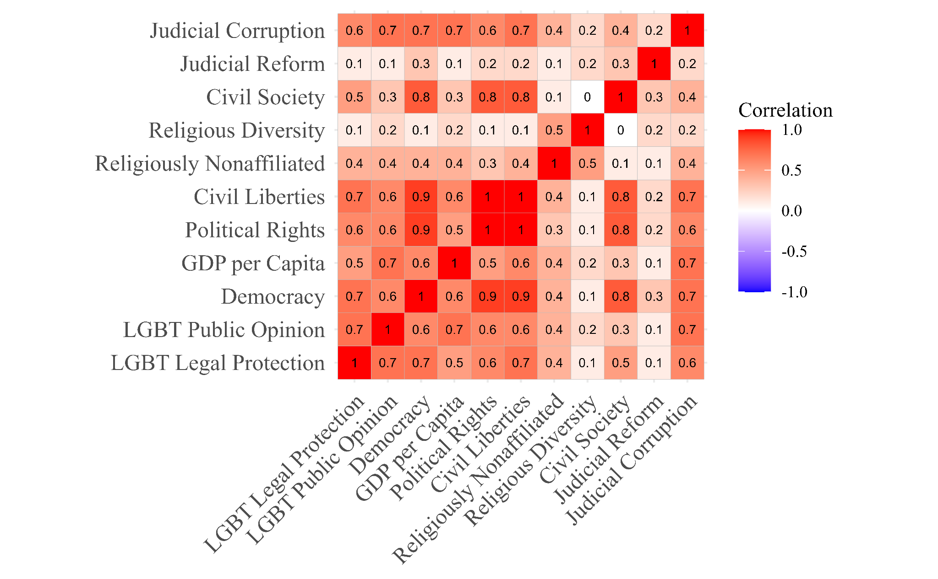

Figure 1. Pearson Correlation Between all Variables

The factors that correlated strongly (i.e. greater than .5) with LGBT legal protections were democracy, civil liberties, political rights, and judicial corruption. These four factors also correlate strongly with democratic governments, supporting Encarnacion and Alvarez’s assertion that democracy is a prerequisite for LGBT legal rights and tolerant public opinion. GDP per capita, civil society strength, and the proportion of a population that is religiously nonaffiliated had weaker but notable correlations as well. When examining LGBT public opinions, there was a notably higher correlation with GDP per capita, rising from .48 to .69, and a weaker correlation with a strong civil society, falling from .46 to .31. This may imply that wealthier nations’ public tends to be more tolerant of LGBT groups but this tolerance does not directly translate into higher political rights. For both LGBT political rights and public opinion, the religious diversity of a nation and how much politicians interfere with the judiciary held a very weak correlation. The strongest overall correlation for LGBT political rights was Freedom House’s civil liberties index, which measures “Freedom of Expression and Belief, Associational and Organizational Rights, Rule of Law, and Personal Autonomy and Individual Rights”.[38] This strong correlation aligns with Encarnacion positing that “the most compelling way in which democracy facilitates gay rights is to provide gay people with the most socially tolerant environment in which to live their sexuality openly and honestly”.[39] Whereas wealth and religion remain important confounding variables, democracy, and its tenets present the strongest relationship with LGBT tolerance. Therefore, it would be surprising and contradictory to see if any non-democratic regimes defy these trends.

# LGBT Tolerance Around the World

To assess whether any non-democratic governments are far more tolerant of LGBT liberties than democracies, Figure 2 compares all countries’ LGBT legal scores to their averaged democracy score with government labels according to the Economist’s democracy index. Appendix A contains all of the second-order polynomial regression parameters for Figures 2 and 3.

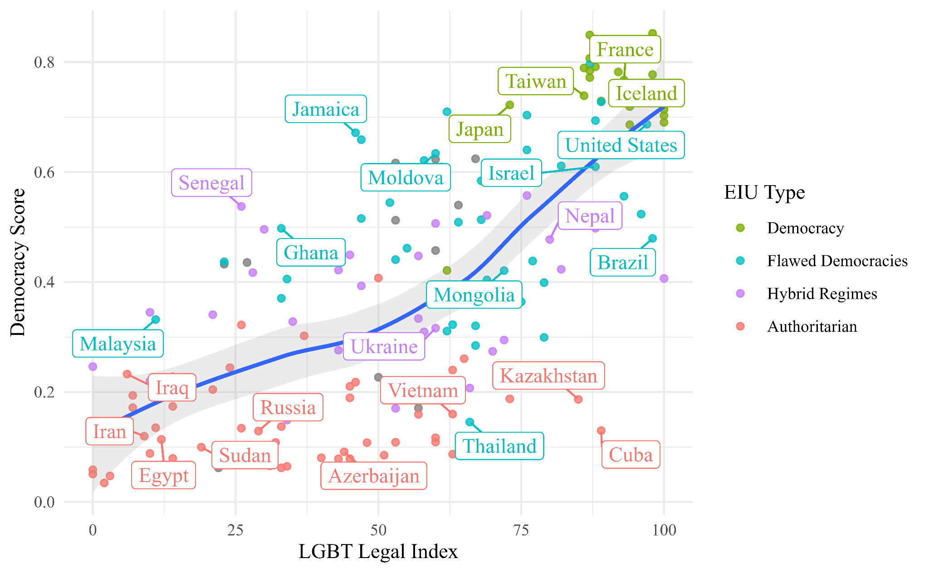

Figure 2. LGBT Legal Index Compared to Averaged Democracy Score With Non-Linear Regression and 95% Confidence Interval

Overall, there is a clear trend between increasing levels of LGBT legal protections corresponding to higher levels of democracy. Democracies have an average legal protection index of 0.75, flawed democracies have an average of 0.53, hybrid regimes have 0.37, and authoritarian regimes have 0.15 on average. Figure 3 illustrates how the levels of LGBT public opinion relate to the democratic score of each nation.

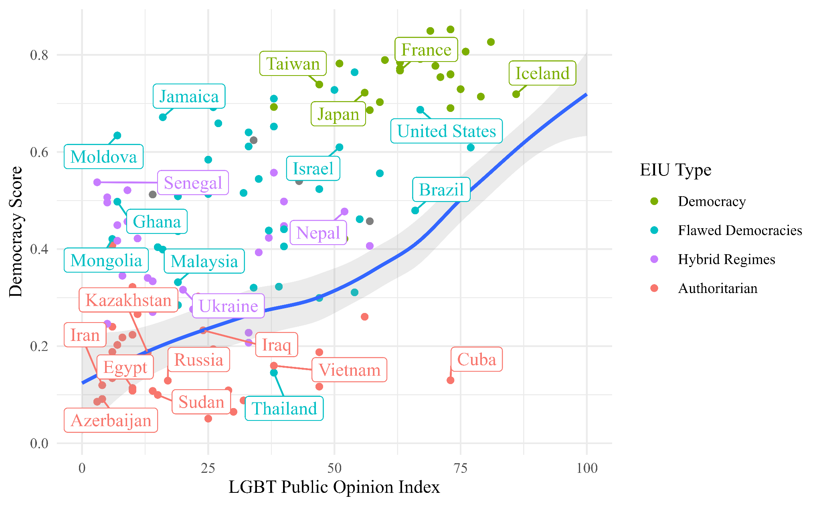

Figure 3. LGBT Public Opinion Index Compared to Averaged Democracy Score With Non-Linear Regression and 95% Confidence Interval

When examining the measured public opinion of each country’s population towards the LGBT community, the data is far more sporadic with almost all nations having lower public opinion scores than legal ones. When considering the example of Bulgaria from Alvarez’s research, the basic principles of democracy (i.e. robust protections for citizens to advocate for their and their country's direction in life) align with stronger legal protections but are far from a guarantee that the citizenry will accept the LGBT community. Therefore, a gap was expected as democratic laws are based on ideals not necessarily the current reality of a nation. Democracies had an average public opinion index of 65.6, flawed democracies had 36.8, hybrid regimes had 20.16, and authoritarian regimes had 19.8 on average. The positive correlation between increasing LGBT liberties and levels of democracy supports Encarnacion and Alvarez’s findings that democracy enables LGBT rights and tolerance. However, there are outlier countries that contradict this trend, which will be examined to understand whether these are exceptions or raise fundamental challenges to established research.

# Case Studies

Outliers were chosen to compare authoritarian non-democracies that had exceptionally high LGBT liberties when compared to democracies with some of the lowest LGBT protections. The chosen outliers were Kazakhstan, Cuba, Ghana, Malaysia, and Jamaica. Kazakhstan and Cuba are both considered authoritarian regimes yet had levels of LGBT legal protections of an average democracy. Malaysia and Jamaica are both considered flawed democracies yet had levels of LGBT legal protections similar to an authoritarian or hybrid regime. These outliers were also chosen because they cover a broad geographic range, helping to control for repressive policies to be solely attributable to their regional status quo. Within the chosen outliers, Kazakhstan had the largest gap between its legal score (85) and public opinion index (13), but the similarly authoritarian Cuba remained remarkably consistent with a legal score of 89 and a public opinion score of 73. Jamaica had the next largest gap between its legal and public scores, 46 and 16 respectively, while Malaysia was the only outlier to have a public opinion score greater than its legal score, 19 and 11 respectively. Lastly, Ghana had a legal index of 33 and a public opinion index of 7. Despite being authoritarian, both Kazakhstan and Cuba had notably higher LGBT protections when compared to the selected democracies. This contradicts the idea that democracy is a prerequisite for LGBT liberties. Using qualitative political and social analysis, each of these outliers is analyzed to illustrate why they deviate from established trends.

## Cuba

Cuba has had a checkered past when it comes to LGBT acceptance. In the 1960s, Fidel Castro’s regime insinuated a homophobic movement that sent gay men to labor camps and pressured them to conform.[40] Yet, in 2022, the same regime that does not hold periodic elections of its leaders nor allows for competing political parties held a general referendum, which passed reforms allowing same-sex couples to marry, adopt children, and created protections against gender-based violence.[41] Even more surprising was the fact that the Cuban regime openly supported the law change and urged people to approve it.[42] Though democratic, this referendum was controversial due to it placing the human rights of the LGBT minority under the mercy of the Cuban majority.[43] Sixty-Seven percent of Cubans voted in favor of the reforms, but it faced stiff resistance from the Cuban evangelical movement and the Catholic church, which both advocated for traditional family and relationship roles.[44] One explanation for the regime initiating this surprising change is that Cuba was undergoing its worst financial crisis since the 1990s.[45] Therefore, this referendum may have been an olive branch to solicit foreign aid, placate a discontent populace, or a combination of both. There was also a concerted push from the Cuban political elite with President Miguel Díaz-Canel and former leader Raúl Castro’s daughter advocating for the referendum.[46] Cuba seems to be an outlier in terms of LGBT tolerance due to a combination of a strong, popular movement in support of these liberties in combination with economic and political pressures. Of course, if Cuba did not have broad popular support or if Cuba’s authoritarian government decided never to hold a referendum, it is hard to see the LGBT community ever winning these newfound rights.

## Kazakhstan

Kazakhstan provides a case where its theoretical legal protections differ wildly from reality. On paper, Kazakhstan seems progressive with its decriminalizing of homosexuality in 1998 when it abolished Soviet-era laws and even made gender-reassignment surgery legal in 2009, but in reality, the LGBT community faces rampant abuse and discrimination from an intolerant police force and public.[47] RadioFreeEurope, interviewed multiple members of the LGBT community who faced threats of rape, being pelted at public gatherings, and extreme isolation within their community.[48] Human Rights Watch noted one explanation for this disparity in presentation and reality is the fact Kazakhstan is deeply invested in international respectability, being a member of the UN Human Rights Council and even bidding against China to host the 2022 Olympic games.[49] Despite Kazakhstan being seemingly responsive to international opinion, the National Commissioner for Human Rights and the National Center for Human Rights have been reluctant to take any serious actions.[50] Therefore, Kazakhstan only seems to be an outlier because it presents a facade of robust legal protections that go undefended while using an intolerant public to oppress the LGBT community. In actuality, Kazakhstan’s legal and social state is aligned with the majority of authoritarian regimes.

## Jamaica

Despite being considered a democracy, albeit a flawed one, Jamaica has a combination of colonial-era repressive laws and deep-rooted social oppression of its LGBT community. Specifically, Jamaica’s anti-LGBT laws are a relic of its time under British colonization, criminalizing buggery (anal sex) and any gross indecency between two males with up to 10 years in prison with hard labor.[51] Human Rights Watch has also documented pervasive social violence with LGBT Jamaicans living in a constant state of fear, being taunted, threatened, and even killed.[52] Some of the worst consequences for the LGBT community do not come from government action but its inaction. Mob violence against LGBT people has been rife with the government consistently failing to prevent or prosecute beating or killings.[53] One explanation for this discrimination and violence is the fact that most of the Jamaican population is deeply religious, about 77% Christian, sowing a climate of violence and unacceptance towards any semblance of sodomy.[54],[55] However, there is international pressure for change with the Inter-American Commission on Human Rights calling on Jamaica to repeal its colonial laws, but as of early 2023, these calls have fallen on deaf ears.[56] For a democracy, Jamaica falls far below average LGBT indices due to its refusal to repeal colonial-era archaic restrictions, being permissive towards and even encouraging acts of violence, and failing to uphold its basic rule of law.

## Malaysia

Malaysia presents a similar picture of a democracy and former British colony that subjects its LGBT community to “ religious, socio-cultural, and legal sanctions against their gender and sexual identities”.[57] Similarly to Jamaica, Malaysia is among half a dozen former British colonies that kept their colonial era anti-sodomy laws.[58] While it is not a Christian nation like Jamaica, Malaysia is a majority Muslim nation with 64% of its population identifying with Islam, which considers homosexuality unacceptable.[59] Furthermore, Malaysia has a religious police force with a dual-track legal system where people can be prosecuted under Islamic law.[60] Reports have noted that government officials in Malaysia ferment a hostile environment against the LGBT community, implementing programs that attempt to cure LGBT people.[61] There has been some protection offered by Malaysia’s judiciary with its high court ruling in February 2021 that a state law banning consensual same-sex conduct was unconstitutional, but the nationwide ban on same-sex relations was left in place.[62] While mixed, this decision was still treated as a success as the federal laws are rarely enforced as most prosecution of the LGBT community comes at the state level.[63] Like Jamaica, Malaysia’s case is emblematic of retention of colonial-era laws, high levels of traditional religious adherence, and a legal system mostly implicit in this persecution.

## Ghana

Lastly, Ghana is also a flawed democracy and former British colony with still-standing anti-sodomy laws and has a majority Christian population at 75%.[64] Like the previous cases, Ghana’s colonial-era rules are rarely enforced but they still hold a chilling effect upon the LGBT community and are largely used by the police for harassment and arbitrary arrests. Yet, in 2022, the Ghana legislature introduced legislation that would criminalize identifying as LGBT, expand flawed conversion therapy, criminalize allying with or advocating for an LGBT person, and add prison sentences for anyone who fails to report LGBT activity.[65] Unlike previous cases, this bill represents a case where international forces helped induce further anti-LGBT restrictions as rightwing conservative groups in Europe and the United States push for its passage.[66] Vice President Kamala Harris spoke for respecting everyone’s human rights, avoiding directly mentioning the bill, during her trip to Ghana in March of 2023, but this was met by the Ghana speaker of parliament calling these statements undemocratic.[67] As with Malaysia and Jamaica the prevalence of LGBT discrimination stems from deeply rooted religious beliefs and draconian laws while the LGBT minority is at the mercy of a political and popular majority that has no incentive to change the status quo, especially when met with meek responses from the international community.

# Conclusion

Being a former colony, particularly British due to its anti-sodomy laws, seems to be a connecting thread between the outlier democracies with particularly low LGBT liberties. Whether or not actually enforced, inherited colonial-era laws present an undemocratic restriction on basic human liberties, but since the LGBT community is a minority in every country in the world, there is little political or popular will to actually make any changes to these laws. Furthermore, all of the outlier democracies explored were majority religious, meaning politicians could exploit persecuting the LGBT minority as deviants attacking traditional family and religious roles in order to secure their political base. When compared to authoritarian states, this reflects democracies can fall behind in terms of LGBT liberties when they allow demagoguing politicians to exploit their minority for political gains, keep in place archaic laws that suppress expression even if not enforced, and are implicitly supported by a quiet international community.

The two outlier authoritarian cases present a less consistent picture that calls into question the assertion that democracy is a prerequisite for LGBT liberties. Cuba is a case where there is broad popular support for the LGBT community that led to expanded legal protections in a popular referendum, yet the entire referendum was a democratic process at the whim of the Cuban regime. The changes in Cuba brought it in line with the broad expansion of LGBT rights seen throughout Latin America, so regional diffusion could be another attributing factor. On the other hand, Kazakhstan reflects an authoritarian regime with LGBT legal protections on paper, which are little more than internationally oriented-lip service. A combination of religious population and implicit government, again breeds an environment where the LGBT minority can be exploited for political gains whereas their plight seems to consistently fail to elicit international action. When considering the reality in Kazakhstan, Cuba seems to be a lone exception, but does this example disprove the idea that democracy is a requirement for LGBT liberties? It can be argued that the referendum in Cuba was the result of democratic and popular undertones surfacing in an otherwise authoritarian regime. Given Cuba’s history of state suppression of the LGBT minority, this referendum is far from a consistent effort by the state to liberalize its LGBT policies, especially when considering that the Cuban populace could have ultimately rejected them. Therefore, this study argues that democracy can be considered a prerequisite for LGBT liberties but only when those rights come from solely the government (i.e. top-down). Cuba demonstrates that democracy was not a requirement when the decision for LGBT liberties came from overwhelming popular support (i.e. bottom-up).

# Contributions

Existing literature has established a clear connection between democracy and LGBT liberties, going as far as to assert that democracy is a prerequisite for LGBT liberties to form. Yet, no research has explored whether there are any cases of authoritarian regimes that disprove this by having exceptionally high LGBT tolerance. This research provides a comparative analysis of any exceptions to this consensus as well as why these exceptions exist.

# Citations

Akinwotu, Emmanuel. “Explainer: What Makes Ghana’s Anti-Gay Bill so Extreme?” *The Guardian*, August 3, 2022, sec. Global development.<https://www.theguardian.com/global-development/2022/aug/03/explainer-what-makes-ghana-draft-anti-gay-lgbtq-bill-so-extreme>.

Álvarez, J. “Democracy and Gender and Sexual Minority Rights: Brazil, Bulgaria and Namibia Compared - How Can We Understand the Importance of Democracy to Furthering LGBTQ Human Rights?” 2019.<https://www.semanticscholar.org/paper/Democracy-and-Gender-and-Sexual-Minority-Rights%3A-we-%C3%81lvarez/ebd4c1a91d43e1dc104dee395b9fe02b838bde69>.

BBC. “Cuba Family Code: Country Votes to Legalise Same-Sex Marriage.” *BBC News*, September 26, 2022, sec. Latin America & Caribbean.<https://www.bbc.com/news/world-latin-america-63035426>.

BBC. “Kamala Harris: What US Vice President talk about LGBTQ rights and why dis dey bore Ghana Speaker of Parliament.” BBC News Pidgin, March 29, 2023.<https://www.bbc.com/pidgin/articles/cqleevlz923o>.

Booth, Effi. “The Most Homophobic Place on Earth? A Look Into the Anti-Homosexuality Culture of Jamaica.” *Perceptions* 4, no. 2 (May 24, 2018): 7–7.<https://doi.org/10.15367/pj.v4i2.109>.

Encarnación, Omar. “Gay Rights: Why Democracy Matters.” Journal of Democracy. Accessed April 18, 2023.<https://www.journalofdemocracy.org/articles/gay-rights-why-democracy-matters/>.

Equaldex. “LGBT Equality Index.” Equaldex. Accessed April 18, 2023.<https://www.equaldex.com/equality-index>.

Freedom House. “Freedom in the World.” Freedom House. Accessed April 18, 2023.<https://freedomhouse.org/report/freedom-world>.

Ghoshal, Neela. “Human Rights Body Calls for Repeal of Jamaica’s Anti-LGBT Laws.” *Human Rights Watch* (blog), February 17, 2021.<https://www.hrw.org/news/2021/02/17/human-rights-body-calls-repeal-jamaicas-anti-lgbt-laws>.

Ghoshal, Neela. “Malaysia’s Highest Court Strikes Down State Gay Sex Ban.” *Human Rights Watch* (blog), February 25, 2021.<https://www.hrw.org/news/2021/02/25/malaysias-highest-court-strikes-down-state-gay-sex-ban>.

Greenwood, Shannon. “The Global Divide on Homosexuality Persists.” *Pew Research Center’s Global Attitudes Project* (blog), June 25, 2020.<https://www.pewresearch.org/global/2020/06/25/global-divide-on-homosexuality-persists/>.

Jerome, Collin, Su-Hie Ting, Yuwana Podin, and Sharifah Sophia bt Wan Ahmad. “Public Receptivity Towards LGBT in Recent Times Malaysia: LGBT Perspectives.” *Multilingual Academic Journal of Education and Social Sciences* 11, no. 14 (March 25, 2021): 371–83.

Knight, Kyle. “‘That’s When I Realized I Was Nobody.’” *Human Rights Watch*, July 23, 2015.<https://www.hrw.org/report/2015/07/23/thats-when-i-realized-i-was-nobody/climate-fear-lgbt-people-kazakhstan>.

Medina, Eduardo. “Cuba Approves Same-Sex Marriage in Historic Vote.” *The New York Times*, September 27, 2022, sec. World.<https://www.nytimes.com/2022/09/26/world/americas/cuba-same-sex-marriage-adoption.html>.

Pappier, Juan, and Cristian Cabrera. “Political Rights for Cubans Should Not Start with a Marriage Equality Referendum.” *Human Rights Watch* (blog), May 15, 2022.<https://www.hrw.org/news/2022/05/15/political-rights-cubans-should-not-start-marriage-equality-referendum>.

Pew Research Center. “The Global Religious Landscape.” *Pew Research Center’s Religion & Public Life Project* (blog), December 18, 2012.<https://www.pewresearch.org/religion/2012/12/18/global-religious-landscape-exec/>.

RadioFreeEurope. “Sexual Minorities In Kazakhstan Hide Who They Are To Avoid Abuse.” *Radio Free Europe/Radio Liberty*, 14:40:07Z, sec. Kazakhstan.<https://www.rferl.org/a/kazakhstan-lgbt-hide-from-abuse/31316186.html>.

Reuters. “FACTBOX: Sodomy Laws in Malaysia and Elsewhere.” *Reuters*, July 17, 2008, sec. World News.<https://www.reuters.com/article/us-malaysia-sodomy-idUSKLR8083620080717>.

Reuters. “Malaysia Questions 18 People Arrested at LGBT Halloween Party.” *Reuters*, October 31, 2022, sec. Asia Pacific.<https://www.reuters.com/world/asia-pacific/malaysia-questions-18-people-arrested-lgbt-halloween-party-2022-10-31/>.

The Economist. “Democracy Index 2022.” Economist Intelligence Unit. Accessed April 18, 2023.<https://www.eiu.com/n/campaigns/democracy-index-2022/>.

Vanderbilt University. “Definitions.” Vanderbilt University. Accessed April 18, 2023.<https://www.vanderbilt.edu/lgbtqi/resources/definitions>.

V-Dem. “The V-Dem Dataset – V-Dem.” Accessed April 18, 2023.<https://www.v-dem.net/data/the-v-dem-dataset/>.

World Bank. “GDP per Capita (Current US$) | Data.” Accessed April 18, 2023.<https://data.worldbank.org/indicator/NY.GDP.PCAP.CD>.

# Appendix A: Statistical Model Variables

LGBT Legal Index and Democracy Score Second Order Polynomial Regression

$y = 0.00004791x^{2} + 0.000895x +0.1636$

With a p-value of 2.2e-16 and an adjusted R-squared of 0.4989

LGBT Public Opinion Index and Democracy Score Second Order Polynomial Regression

$y = 0.00005222x^{2} + 0.002280x +$ 0.2675

With a p-value of 7.498e-16 and an adjusted R-squared of 0.3812

1. Vanderbilt University. “Definitions.” Vanderbilt University. Accessed April 18, 2023. https://www.vanderbilt.edu/lgbtqi/resources/definitions.
2. Álvarez, J. “Democracy and Gender and Sexual Minority Rights: Brazil, Bulgaria and Namibia Compared - How Can We Understand the Importance of Democracy to Furthering LGBTQ Human Rights?,” 2019. https://www.semanticscholar.org/paper/Democracy-and-Gender-and-Sexual-Minority-Rights%3A-we-%C3%81lvarez/ebd4c1a91d43e1dc104dee395b9fe02b838bde69.
3. Encarnación, Omar. “Gay Rights: Why Democracy Matters.” Journal of Democracy. Accessed April 18, 2023. https://www.journalofdemocracy.org/articles/gay-rights-why-democracy-matters/.
4. Álvarez, J. “Democracy and Gender and Sexual Minority Rights: Brazil, Bulgaria and Namibia Compared - How Can We Understand the Importance of Democracy to Furthering LGBTQ Human Rights?,” 2019. https://www.semanticscholar.org/paper/Democracy-and-Gender-and-Sexual-Minority-Rights%3A-we-%C3%81lvarez/ebd4c1a91d43e1dc104dee395b9fe02b838bde69.
5. Id.
6. Id.
7. Id.
8. Id.
9. Id.
10. Id.
11. Id.
12. Id.
13. Id.
14. Id.
15. Id.
16. Id.
17. Id.
18. Encarnación, Omar. “Gay Rights: Why Democracy Matters.” Journal of Democracy. Accessed April 18, 2023. https://www.journalofdemocracy.org/articles/gay-rights-why-democracy-matters/.
19. Id.
20. Id.
21. Id.
22. Id.
23. Id.
24. Id.
25. Id.
26. Greenwood, Shannon. “The Global Divide on Homosexuality Persists.” Pew Research Center’s Global Attitudes Project (blog), June 25, 2020.
27. Id.
28. Id.
29. Id.
30. Equaldex. “LGBT Equality Index.” Equaldex. Accessed April 18, 2023. https://www.equaldex.com/equality-index.
31. Freedom House. “Freedom in the World.” Freedom House. Accessed April 18, 2023. https://freedomhouse.org/report/freedom-world.
32. V-Dem. “The V-Dem Dataset – V-Dem.” Accessed April 18, 2023. https://www.v-dem.net/data/the-v-dem-dataset/.
33. Pew Research Center. “The Global Religious Landscape.” Pew Research Center’s Religion & Public Life Project (blog), December 18, 2012. https://www.pewresearch.org/religion/2012/12/18/global-religious-landscape-exec/.
34. World Bank. “GDP per Capita (Current US$) | Data.” Accessed April 18, 2023. https://data.worldbank.org/indicator/NY.GDP.PCAP.CD.
35. The Economist. “Democracy Index 2022.” Economist Intelligence Unit. Accessed April 18, 2023. https://www.eiu.com/n/campaigns/democracy-index-2022/.
36. V-Dem. “The V-Dem Dataset – V-Dem.” Accessed April 18, 2023. https://www.v-dem.net/data/the-v-dem-dataset/.
37. Id.
38. Freedom House. “Freedom in the World.” Freedom House. Accessed April 18, 2023. https://freedomhouse.org/report/freedom-world.
39. Encarnación, Omar. “Gay Rights: Why Democracy Matters.” Journal of Democracy. Accessed April 18, 2023. https://www.journalofdemocracy.org/articles/gay-rights-why-democracy-matters/.
40. Medina, Eduardo. “Cuba Approves Same-Sex Marriage in Historic Vote.” The New York Times, September 27, 2022, sec. World. https://www.nytimes.com/2022/09/26/world/americas/cuba-same-sex-marriage-adoption.html.
41. Id.
42. BBC. “Cuba Family Code: Country Votes to Legalise Same-Sex Marriage.” *BBC News*, September 26, 2022, sec. Latin America & Caribbean.<https://www.bbc.com/news/world-latin-america-63035426>.
43. Pappier, Juan, and Cristian Cabrera. “Political Rights for Cubans Should Not Start with a Marriage Equality Referendum.” Human Rights Watch (blog), May 15, 2022. https://www.hrw.org/news/2022/05/15/political-rights-cubans-should-not-start-marriage-equality-referendum.
44. Medina, Eduardo. “Cuba Approves Same-Sex Marriage in Historic Vote.” The New York Times, September 27, 2022, sec. World. https://www.nytimes.com/2022/09/26/world/americas/cuba-same-sex-marriage-adoption.html.
45. Id.
46. BBC. “Cuba Family Code: Country Votes to Legalise Same-Sex Marriage.” BBC News, September 26, 2022, sec. Latin America & Caribbean. https://www.bbc.com/news/world-latin-america-63035426.
47. RadioFreeEurope. “Sexual Minorities In Kazakhstan Hide Who They Are To Avoid Abuse.” Radio Free Europe/Radio Liberty, 14:40:07Z, sec. Kazakhstan. https://www.rferl.org/a/kazakhstan-lgbt-hide-from-abuse/31316186.html.
48. Id.
49. Knight, Kyle. “‘That’s When I Realized I Was Nobody.’” Human Rights Watch, July 23, 2015. https://www.hrw.org/report/2015/07/23/thats-when-i-realized-i-was-nobody/climate-fear-lgbt-people-kazakhstan.
50. Id.
51. Ghoshal, Neela. “Human Rights Body Calls for Repeal of Jamaica’s Anti-LGBT Laws.” Human Rights Watch (blog), February 17, 2021. https://www.hrw.org/news/2021/02/17/human-rights-body-calls-repeal-jamaicas-anti-lgbt-laws.
52. Id.
53. Booth, Effi. “The Most Homophobic Place on Earth? A Look Into the Anti-Homosexuality Culture of Jamaica.” Perceptions 4, no. 2 (May 24, 2018): 7–7. https://doi.org/10.15367/pj.v4i2.109.
54. Pew Research Center. “The Global Religious Landscape.” Pew Research Center’s Religion & Public Life Project (blog), December 18, 2012. https://www.pewresearch.org/religion/2012/12/18/global-religious-landscape-exec/.
55. Booth, Effi. “The Most Homophobic Place on Earth? A Look Into the Anti-Homosexuality Culture of Jamaica.” Perceptions 4, no. 2 (May 24, 2018): 7–7. https://doi.org/10.15367/pj.v4i2.109.
56. Ghoshal, Neela. “Human Rights Body Calls for Repeal of Jamaica’s Anti-LGBT Laws.” Human Rights Watch (blog), February 17, 2021. https://www.hrw.org/news/2021/02/17/human-rights-body-calls-repeal-jamaicas-anti-lgbt-laws.
57. Jerome, Collin, Su-Hie Ting, Yuwana Podin, and Sharifah Sophia bt Wan Ahmad. “Public Receptivity Towards LGBT in Recent Times Malaysia: LGBT Perspectives.” Multilingual Academic Journal of Education and Social Sciences 11, no. 14 (March 25, 2021): 371–83.
58. Reuters. “FACTBOX: Sodomy Laws in Malaysia and Elsewhere.” Reuters, July 17, 2008, sec. World News. https://www.reuters.com/article/us-malaysia-sodomy-idUSKLR8083620080717.
59. Pew Research Center. “The Global Religious Landscape.” Pew Research Center’s Religion & Public Life Project (blog), December 18, 2012. https://www.pewresearch.org/religion/2012/12/18/global-religious-landscape-exec/.
60. Reuters. “Malaysia Questions 18 People Arrested at LGBT Halloween Party.” Reuters, October 31, 2022, sec. Asia Pacific. https://www.reuters.com/world/asia-pacific/malaysia-questions-18-people-arrested-lgbt-halloween-party-2022-10-31/.
61. Id.
62. Ghoshal, Neela. “Malaysia’s Highest Court Strikes Down State Gay Sex Ban.” Human Rights Watch (blog), February 25, 2021. https://www.hrw.org/news/2021/02/25/malaysias-highest-court-strikes-down-state-gay-sex-ban.
63. Id.
64. Pew Research Center. “The Global Religious Landscape.” Pew Research Center’s Religion & Public Life Project (blog), December 18, 2012. https://www.pewresearch.org/religion/2012/12/18/global-religious-landscape-exec/.
65. Akinwotu, Emmanuel. “Explainer: What Makes Ghana’s Anti-Gay Bill so Extreme?” The Guardian, August 3, 2022, sec. Global development. https://www.theguardian.com/global-development/2022/aug/03/explainer-what-makes-ghana-draft-anti-gay-lgbtq-bill-so-extreme.
66. Id.
67. BBC. “Kamala Harris: What US Vice President talk about LGBTQ rights and why dis dey bore Ghana Speaker of Parliament.” BBC News Pidgin, March 29, 2023. https://www.bbc.com/pidgin/articles/cqleevlz923o.